Course Title : Big Data Analytics
Course Code : Z1AMC 702

Name: NISARG SATHWARA Registration No: 2511042210001

Experiment 4: Word Count of All Files Using Hadoop MapReduce

1) Objective
To perform a Word Count operation on multiple text files stored in HDFS using the Hadoop MapReduce framework and display the frequency of each word.

2) Procedure
Step 1: Create Input Text Files
Step 2: Verify the Files
Step 3: Create HDFS Input Directory
Step 4: Upload Files to HDFS
Step 5: Run the Word Count Program
Step 6: View the Output

3) Screen Short
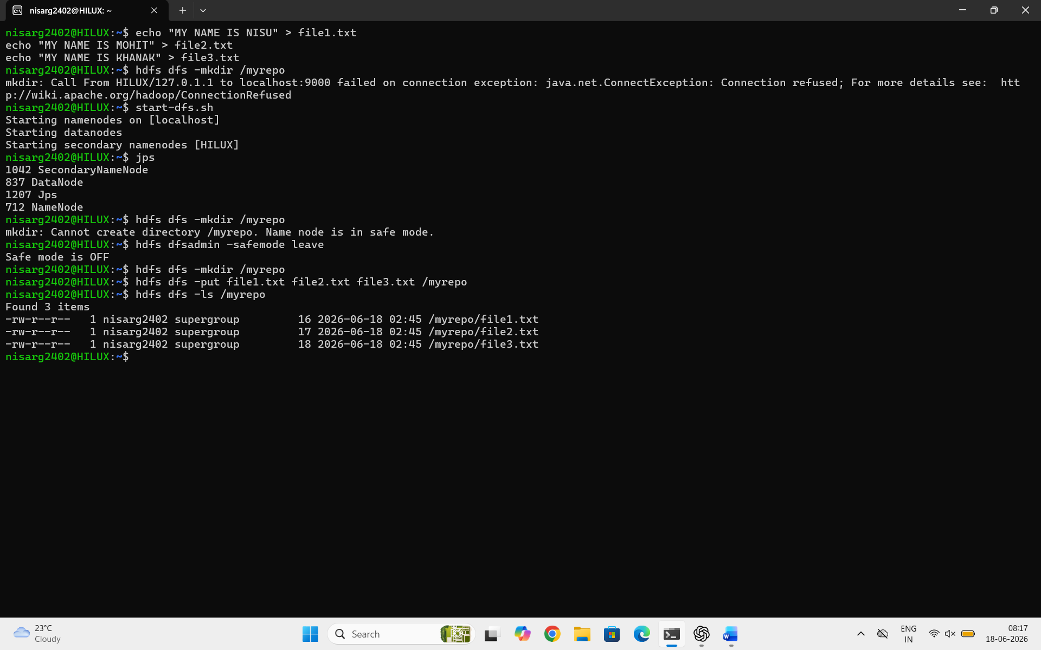
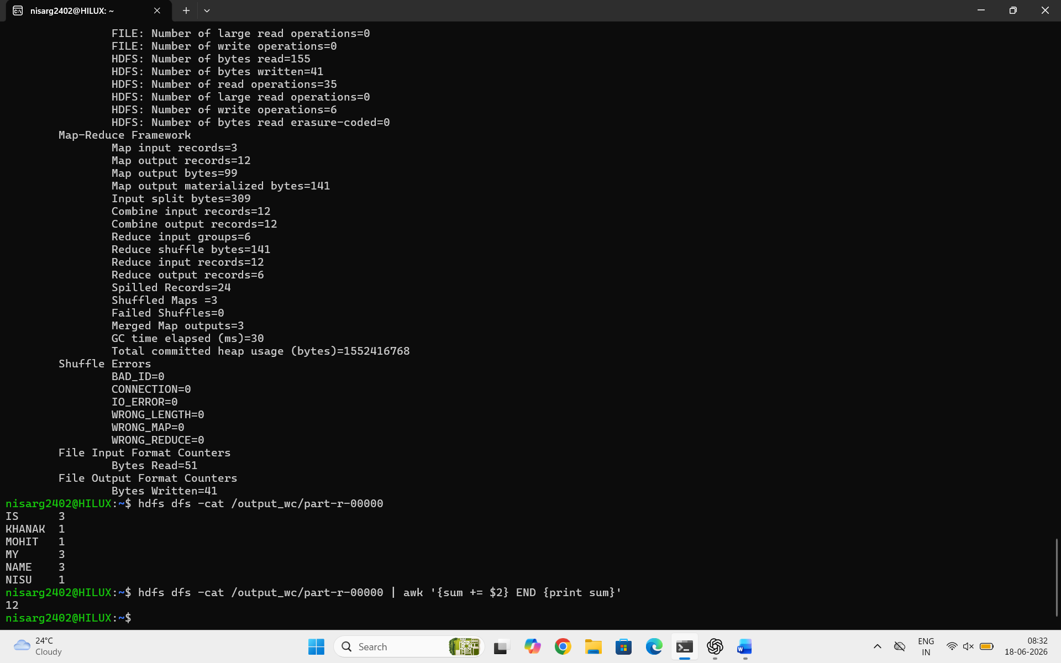

4) Conclusion
The Word Count MapReduce program was successfully executed on multiple text files stored in HDFS. Hadoop processed the files in a distributed manner and generated the frequency count of each word. The experiment demonstrated the working of the Map and Reduce phases and showed how Hadoop can efficiently process large datasets.

